**Alexandria Nikirk - Z23677057**

**February 7, 2024**

**COP4808 – Full Stack Web Development**

**Lab 3**

Table of Contents

Step 1 2

Step 2 3

Step 3 6

Step 4 9

Step 5 11

Stretch Feature 14

# Step 1

*BaristaForm.jsx file*

*App.jsx file (added title and BaristaForm component)*

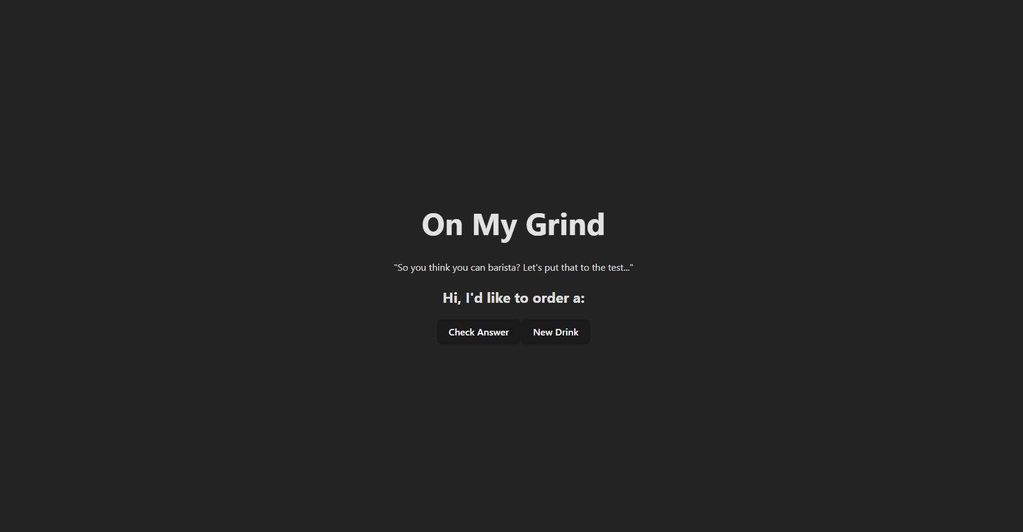

*Webpage image*

# Step 2

*RecipeChoices.jsx file (new file added clickable choices)*

*BaristaForm.jsx file (new)*

*Webpage image*

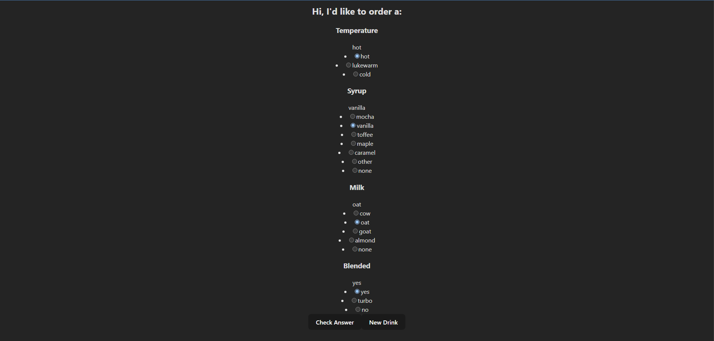

*Webpage image (when choices clicked on)*

# Step 3

*BaristaForm.jsx file (made new drink and next drink buttons functional)*

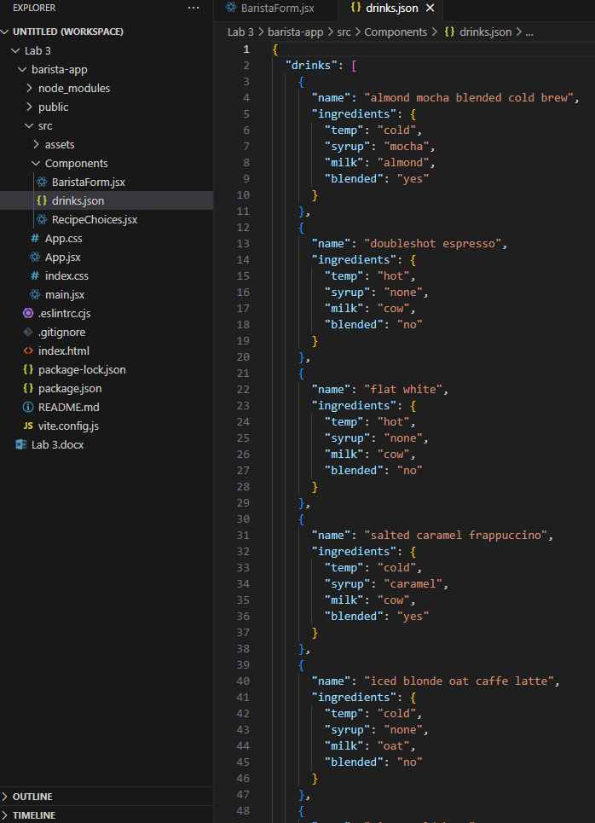

*drinks.json file (in components directory downloaded from GitHub link provided)*

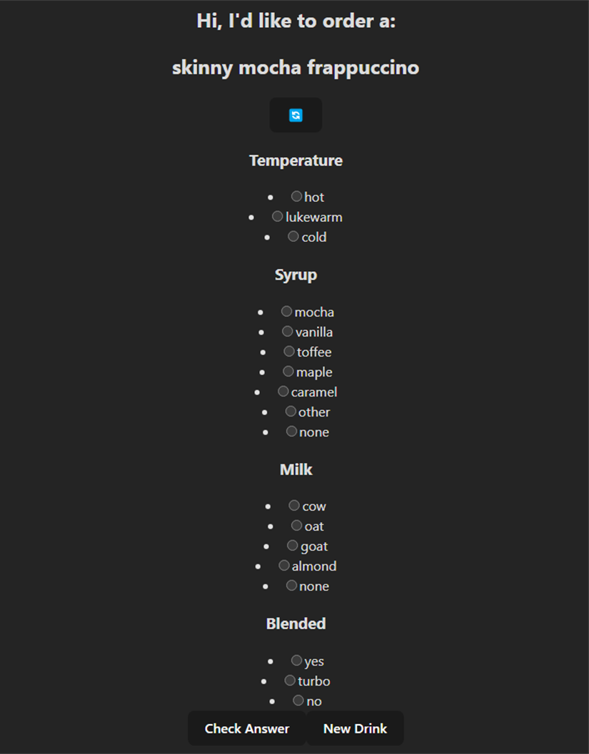

*Webpage image*

# Step 4

*BaristaForm.jsx file (added functionality to check user submission against form)*

# Step 5

*BaristaForm.jsx (added mini-container to every ingredient and added container to entire form)*

*BaristaForm.css file (adds css styling)*



*Webpage gif*

# Stretch Feature

*RecipeChoices.jsx (changed radio buttons to input text box)*

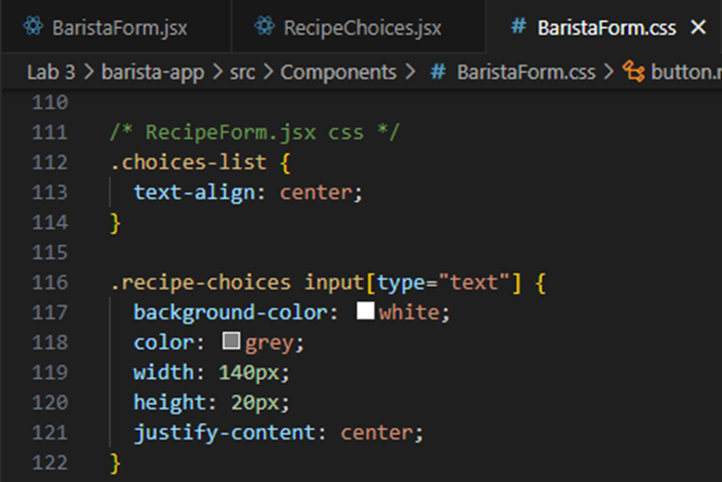

*BaristaForm.css file (formatted choices and text box)*

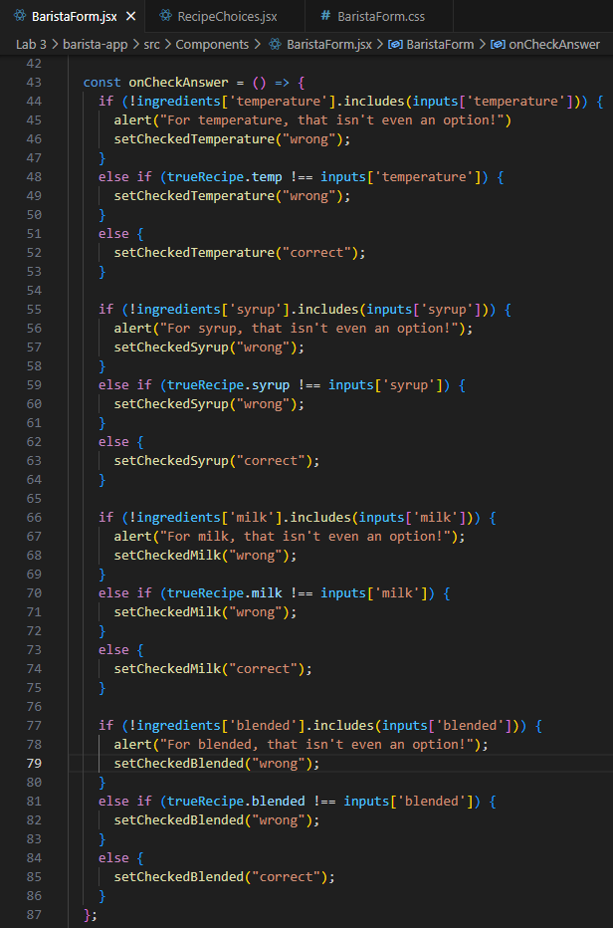

*BaristaForm.jsx file (input and choice validation)*



*Webpage gif*